my first markdown

# 前言

今天虽然外面下着雨，但是我的心情很激动，国为，我马上要学会文艺化编程了。

# 第一章

第一堂 课我们学习了一个数据集ansombe。现在我用这个数据来练习一下。先看看描述性

#心情很好  
anscombe

## x1 x2 x3 x4 y1 y2 y3 y4  
## 1 10 10 10 8 8.04 9.14 7.46 6.58  
## 2 8 8 8 8 6.95 8.14 6.77 5.76  
## 3 13 13 13 8 7.58 8.74 12.74 7.71  
## 4 9 9 9 8 8.81 8.77 7.11 8.84  
## 5 11 11 11 8 8.33 9.26 7.81 8.47  
## 6 14 14 14 8 9.96 8.10 8.84 7.04  
## 7 6 6 6 8 7.24 6.13 6.08 5.25  
## 8 4 4 4 19 4.26 3.10 5.39 12.50  
## 9 12 12 12 8 10.84 9.13 8.15 5.56  
## 10 7 7 7 8 4.82 7.26 6.42 7.91  
## 11 5 5 5 8 5.68 4.74 5.73 6.89

summary(anscombe)

## x1 x2 x3 x4   
## Min. : 4.0 Min. : 4.0 Min. : 4.0 Min. : 8   
## 1st Qu.: 6.5 1st Qu.: 6.5 1st Qu.: 6.5 1st Qu.: 8   
## Median : 9.0 Median : 9.0 Median : 9.0 Median : 8   
## Mean : 9.0 Mean : 9.0 Mean : 9.0 Mean : 9   
## 3rd Qu.:11.5 3rd Qu.:11.5 3rd Qu.:11.5 3rd Qu.: 8   
## Max. :14.0 Max. :14.0 Max. :14.0 Max. :19   
## y1 y2 y3 y4   
## Min. : 4.260 Min. :3.100 Min. : 5.39 Min. : 5.250   
## 1st Qu.: 6.315 1st Qu.:6.695 1st Qu.: 6.25 1st Qu.: 6.170   
## Median : 7.580 Median :8.140 Median : 7.11 Median : 7.040   
## Mean : 7.501 Mean :7.501 Mean : 7.50 Mean : 7.501   
## 3rd Qu.: 8.570 3rd Qu.:8.950 3rd Qu.: 7.98 3rd Qu.: 8.190   
## Max. :10.840 Max. :9.260 Max. :12.74 Max. :12.500

print("hello")

## [1] "hello"

plot(anscombe$x1,anscombe$y1)

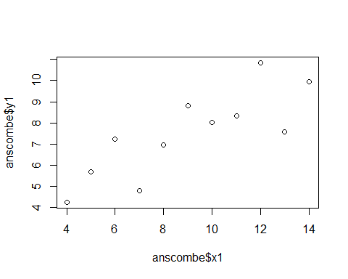

*斜体用星号* #数学公式用

# 前言 ##分析anscombe数据 ##描述统计分析 ##回归方程(y1~x1) ##画图 ##结论

cor(anscombe)

## x1 x2 x3 x4 y1 y2  
## x1 1.0000000 1.0000000 1.0000000 -0.5000000 0.8164205 0.8162365  
## x2 1.0000000 1.0000000 1.0000000 -0.5000000 0.8164205 0.8162365  
## x3 1.0000000 1.0000000 1.0000000 -0.5000000 0.8164205 0.8162365  
## x4 -0.5000000 -0.5000000 -0.5000000 1.0000000 -0.5290927 -0.7184365  
## y1 0.8164205 0.8164205 0.8164205 -0.5290927 1.0000000 0.7500054  
## y2 0.8162365 0.8162365 0.8162365 -0.7184365 0.7500054 1.0000000  
## y3 0.8162867 0.8162867 0.8162867 -0.3446610 0.4687167 0.5879193  
## y4 -0.3140467 -0.3140467 -0.3140467 0.8165214 -0.4891162 -0.4780949  
## y3 y4  
## x1 0.8162867 -0.3140467  
## x2 0.8162867 -0.3140467  
## x3 0.8162867 -0.3140467  
## x4 -0.3446610 0.8165214  
## y1 0.4687167 -0.4891162  
## y2 0.5879193 -0.4780949  
## y3 1.0000000 -0.1554718  
## y4 -0.1554718 1.0000000

fit <- lm(y1~x1,anscombe)  
plot(anscombe$x1,anscombe$y1)  
abline(fit)

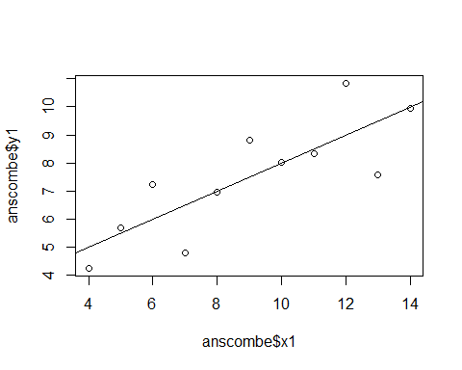

#setClass("employee",representation(name="character",salary="numeric",union="loical"))  
#"employee"  
#joe <- new("employee",name="joe")  
#mean  
  
  
  
getwd()

## [1] "C:/Users/heyouxin/Desktop"

#UseMethod  
  
  
   
data1 <- read.csv("cor.csv")  
View(data1)  
  
x <- c(1:10)  
y <- c(10:1)  
gra1 <- plot(x,y,xlab="x",ylab="y")

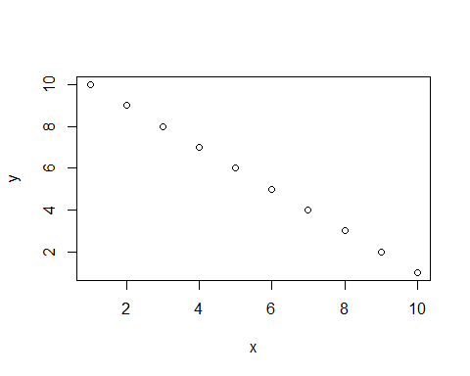

hist(x)

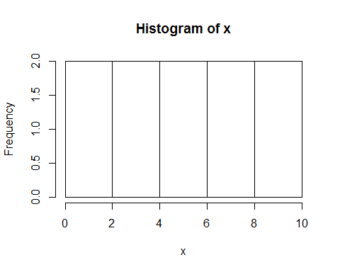

ls()

## [1] "data1" "fit" "gra1" "x" "y"

#?strsplit